**E-HEALTHCARE MONITORING USING MACHINE LEARNING**

Sayon Chakraborty Shubham

Department of Computer Science Department of Computer Science

Sharda University Greater Noida Sharda University Greater Noida

Shreya Singh

Department of Computer Science

Sharda University Greater Noida

**ABSTRACT**

**The patient data is classified using the classification approach. Many researchers pioneered a wide range of healthcare techniques, from diagnostics to treatment. On the basis of an effective e-health monitoring system, therapy and prevention may be provided however, the degree of accuracy did not improve. In the sphere of portable and smart IoT devices, the healthcare sector has seen significant advancement. The analysis of huge patient data sets by clustering and classification of the data is one of the ways that has been employed to offer this E-health monitoring system a new direction. Clustering is the process of creating a comprehensive dataset of patients with a specific ailment and then analysing their various data points. The data of the patients is then classified using classification. Many strategies have been explored to enhance the E-Health monitoring system, but none of them has shown to be effective in solving the problem. Many academics are analysing a large amount of data on patients in order to remedy the problem with the health-monitoring technologies using different machine learning approaches, adequate accuracy may be reached. Machine learning techniques are significantly more efficient for patient health monitoring and provide effective performance of “feature selection, classification, and clustering of data” by sifting through a massive database of patient information.**

*Keywords: - Clustering of data, Machine Learning, Health monitoring systems, set of algorithms, IOT devices*

**INTRODUCTION**

Health monitoring system is one of the most important I set in the future for the identification and prevention of illnesses like diabetes in nations like India, which has the highest number of diabetic patients in the world, utilising big data and machine learning methods. One of the most important innovations in the healthcare business is the usage of IoT Devices, which allows patients' vitals to be measured in a cost-effective manner. There are a variety of health monitoring systems available on the market. We're going through things like "activity tracking," "SpO2 level," "heartbeat monitoring," and so on. There is a large data set in the suggested system via which it can anticipate.

The proposed system has a large data set through which it can predict the disease criteria on which the patient will fall, as well as recommend a hilly diet and rate of exercise in the patient's daily life. The goal is to make this system more and more accurate by analysing a large patient data set. The first approach is to go through with the diabetes prediction and other diseases prediction that the patient will fall into. The system will attempt to forecast the outcome with increasing accuracy in order to provide a better consumer interactive experience. Including this it will assists the patient in understanding what foods are required and what steps and diet should be followed to be healthy. The system is analyzing the data that is available and through which it can predicts the disease and what are the steps and diet should one follow to get rid of it or be that in control. The available devices that are present in the market are basically based on IOT but very of them are precise and accurate which will cost the customer’s pocket. Beside this the devices need a lot of technical and not easy to use, The Nobel approach is to make a better user-friendly E-health Monitoring system that is precise and cost effective. [1] In today's Internet world, people are frequently confused about diseases, and a large amount of data on the internet is frequently unable to effectively answer the question of a patient's symptoms due to a lack of required dataset. In this proposed system, the symptoms are entered by the patient themselves, and the system predicts which disease the patient may be suffering from based on that information. The suggested system issue statement is based on the notion that individuals nowadays are highly interested in learning what type of sickness they have, even if their symptoms are moderate. We used to look for solutions all over the internet, but we never received the ideal answer; instead, we got a lot of unwelcome results, which made us feel even more anxious and afraid. So here is the proposed system, which is a machine learning based python IDE based system that will receive the user's symptoms data and categorise it using its many classification and other primary algorithm techniques to predict the patient's anticipated disease. To make the prediction a little clearer and easier, it uses two training and testing datasets. To make the prediction a little clearer and simpler to comprehend by the user, it uses two training and testing datasets. The user may enter a set of five symptoms, and the system will analyse which is the precise predictable disease for the provided collection of symptoms. There are three main machine algorithms that are employed to increase the system's accuracy.

**LITREATURE SURVEY**

Using big data and machine learning approaches, a health monitoring system is one of the most essential set in the future for the detection and prevention of illnesses like diabetes in countries like India, which has the greatest number of diabetic patients in the world. The use of IoT Devices, which allows patients' vitals to be measured in a cost-effective manner, is one of the most essential breakthroughs in the healthcare industry. On the market, there are a range of health monitoring systems to choose from. "Activity tracking," "SpO2 level," "heartbeat monitoring," and other terms are being discussed. The recommended system has a vast data collection from which it can forecast.

|  |  |  |  |  |  |
| --- | --- | --- | --- | --- | --- |
| **TITLE** | **AUTHOR** | **Software / Hardware Requirements** | **ALGORITHM** | **FINDING/ Achievement** | **DRAWBACK** |
| **“Smart Health Monitoring and Management Using Internet of**  **Things, Artificial Intelligence with Cloud Based Processing”** | Mr. Ravish Gupta, Dept. of Electronics and Communication Engineering | Internet of things, Cloud Platforms, Artificial Intelligence, Supervised  Convolutional Neural Networks, Sensors and Actuators, Microcontrollers and Electro-  Cardiogram. | Machine learning techniques,  Un-supervised machine learning techniques  Deep learning | The healthcare industry has been greatly impacted by the Internet of Things (IoT) and Artificial Intelligence (AI). In such burgeoning technical applications, wearable sensors are utilised to monitor human health. The use of such technology is rapidly expanding, improving the chances of early and real-time diagnosis. | Because of a lack of resources and emergency aid that should be offered when a patient is in danger, life expectancy has declined significantly as a result of the expanding population. [2] |
| **“STUDY ON AN IOT BASED SECURE”**  **“HEALTHCARE MONITORING SYSTEM UNING**  **CRYPTOGRAPHY”** | Mr. Adars  Vinayaka Mission’s  Kadakkal, Kollam, Kerala | Internet of Things ,  Sensor network , | Healthcare applications ,  Semantic Web technology, | Wireless medical sensor networks can be used to monitor patients, making healthcare applications a viable field for wireless sensor networks (WMSNs). | The disease prediction arc is so small it only recommends and predicts the activity and the heart rate monitoring.[3] |
| **“REAL TIME HEALTH MONITORING USING IOT WITH INTEGRATION OF MACHINE LEARNING APPROACH”** | G Sahithi , P Vinayasree , Pallati Narsimhulu | Iot-Internet of Things, Monitoring, Sensors, Anatomy, Physiology, Cardiovascular | Machine Learning approach.  Multiple Linear Regression Algorithm**.** Random Forest Algorithm.  Support Vector Machine | A healthcare monitoring system uses digital sensors and IoT devices to improve the traditional healthcare system's patient information collection. This method builds analytic models using Machine Learning algorithms. The R programming language is used to determine the likelihood of heart disease analysis. Using an Arduino, a continuous monitoring system was proposed. | Heavy computation and need of an expertise consultation needed to access this particular device. [4] |
| **“Development of Smart Healthcare Monitoring System in IoT**  **Environment”** | Md. Milon Islam ,  Ashikur Rahaman ,  Md. Rashedul Islam1 | Internet of things · Sensors ·  ESP32,  Pulse sensor, temperature sensor, BP sensor, ECG sensor, and raspberry pi. | Creating a IOT based health monitoring device with the help  different sensors | Internet of Things (IoT) technology enables the development of healthcare from face-to-face consulting to telemedicine. In this machine, 5 sensors are used to seize the records from health center surroundings. | The major drawback of the system is that no interfaces for data Visualization are need to be develop. [5] |
| **“Analysis on E-Healthcare Monitoring System with Iot and Big Patient Data”** | V. Deepa, K. Rajeswari | Internet of Things, telemedicine, e-health  monitoring system, prevention, artificial neural network | Use of IOT interconnected with the Artififcial nueral networks , Deep learning | Big statistics are notably utilized in healthcare technique medical doctors are without difficulty analysed the affected person circumstance in a brief time. Healthcare tracking gadget in hospitals has acting the e-healthcare tracking gadget with massive statistics. Characteristic selection, clustering and affected person category with affected person statistics. | Nueral network and deep learning need a system which can come with heavy computataion and analyzing a big dataset is not easy and always a expertise need by side. [6] |
| **“IoT based Health Monitoring System using Machine Learning”**  **“Real Time Machine**  **Health Monitoring System Using Machine Learning and IOT”** | Srivardhan Reddy K1, Sidaarth R2, Sai Aneesh Reddy3, Dr. Rajashree Shettar 4  Tzen Ket Wong ,Hou Kit Mun, Swee King Phang, Kai Lok Lum and Wei Qiang Tan | IoT, Machine Learning  IOT Based Devices , Neural Network and virtual machine | Using of IOT devices to get the patient health diagnosis and through machine learning analyzing the data.  Iot based hardware encoded in the artififcal nueral network and by using VM ware power is given to the system | The idea of Internet of Things and Machine Learning are notably used with inside the area of scientific analysis and healthcare to be able to reveal the circumstance of a affected person.  Using of nueral anetworks and VM ware to give out a actual and better prediction. | The use of data is not much may cause malfunction in prediction. [7]  Using of this framework make it much more hardware dependent and costly too. [8] |

The system is evaluating the data available and predicting the ailment, as well as the measures and diet that need be followed to get rid of it or keep it under control. The existing gadgets on the market are mostly based on IOT, but few of them are exact and accurate, putting a strain on the customer's wallet. Aside from that, the devices require a lot of technical knowledge and are difficult to operate. The Nobel strategy is to create a more user-friendly, precise, and cost-effective E-health Monitoring system. People are frequently puzzled by diseases in today's Internet age, and a great volume of material on the internet is frequently unable to adequately address the query.

**Methodology**

The proposed system, which is a machine learning based python IDE based system that will receive the user's symptoms data and categorise it using its many classification and other primary algorithm techniques to predict the patient's anticipated disease. To make the prediction a little clearer and easier, it uses two training and testing datasets. To make the prediction a little clearer and simpler to comprehend by the user, it uses two training and testing datasets. The user may enter a set of five symptoms, and the system will analyse which is the precise predictable disease for the provided collection of symptoms. There are three main machine algorithms that are employed to increase the system's accuracy.

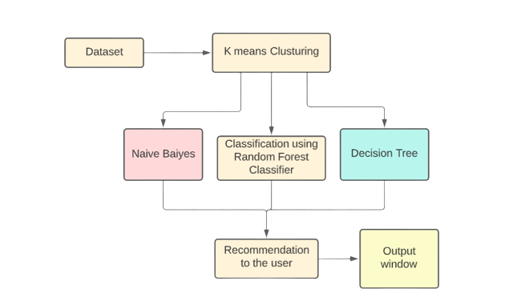

Figure 1. Workflow of the system

1. **Workflow**

The dataset for the proposed system is collected as two csv files that contain informative information about various types of diseases and their severe symptoms, and by analysing the different symptoms and using classifier techniques, the prediction of the particular disease can be done. There are several machine learning prediction and classification techniques used to perform the prediction of the disease, which increases the system's accuracy. The following are some of the classification approaches that were utilised to create the prediction system:

1.1 **Content Filtering Method:-**In order to produce predictions, the content-based technique is a domain-dependent algorithm that emphasizesanalyzing the attributes of objects. When Pages, articles, and news are presented as files, and Content-based filtering is without a doubt the most profitable filtering method. In the event of an emergency, the recommendation is based on a content-based filtering method. Characteristics obtained from data in the objects are used to create human profiles. A person who has previously investigated

1.2 **Collaborative based Filtering Method** - Collaborative filtering is a domain-agnostic prediction method for media such as movies and music that isn't well represented by metadata. The collaborative filtering method saves user preferences for entries in a database (user-item matrix). In a newer, narrower definition, collaborative filtering is a method of collecting preferences or taste information from a large number of users in order to develop automatic predictions (filtering) about a user's interests (collaborating). The collaborative filtering technique's core premise is that if two persons A and B have the same viewpoint on one issue, A is more likely than a randomly selected individual to share B's viewpoint on a different topic. [9]

1. **Memory-based Filtering Method-** The user's prior ratings are important in his hunt for a neighbour who shares his interests. When a person's neighbour is recognised, a variety of algorithms that take into account the preferences of friends may be utilised to provide suggestions. These tactics have produced considerable success in real-world circumstances due to their applicability.
2. **Model-based Filtering Method -** In this technique, models are constructed using various data mining and machine learning methods to predict user ratings of unrated items. There are a number of model-based CF approaches to choose from. Bayesian networks, clustering models, singular value decomposition, probabilistic latent semantic analysis, multiple multiplicative factors, latent Dirichlet allocation, and Markov decision process based models are all examples of latent semantic models.

**1.3 Hybrid Filtering Method -** Memory-based and model-based CF algorithms are used in a number of applications. Traditional CF techniques have limitations, and these methods increase prediction performance. Importantly, they address CF concerns such sparsity and data loss. However, the complexity and cost of implementation have grown. The majority of commercial recommender systems, such as Google's news recommender system, are hybrid.

**1.4 Naïve Baiyes -** The strategy of creating classifiers in models to assign through a representative vector value using a limited number of class levels is known as naive bias. There is no other approach in which a large number of algorithms are based on the same premise as the night bias classifier, which is considered to be independent of the features assigned to its class variable. This is one of the most extensively used machine learning approaches for data categorization and filtration, with applications in neural networks and heavy computing. [10]

**1.5 Decision Tree -** The decision tree is one of the most powerful and extensively used tools for classification and prediction of data in machine learning. It appears like a tree-like structure and creates a flow chart with the internal node and attribute asset, with each branch representing a different type of data. Starting at the class level, this is the entry used to categorise the data, and each node is its terminal node. By dividing them into three groups and leaving a comment, the data is classified at the beginning of the tree node, and the attribute supplied by the node is verified. The same method will be followed as you move up the tree branch based on its attribute value. [11]

1. **Implementation of the proposed system**

In the proposed system, we use the Python IDE to import all of the training and testing datasets, and we use various types of classifiers in the needed labels to make illness predictions using various types of machine learning approaches. The following is a step-by-step guide to putting the system in place:

**Step 1. Header Files Used**

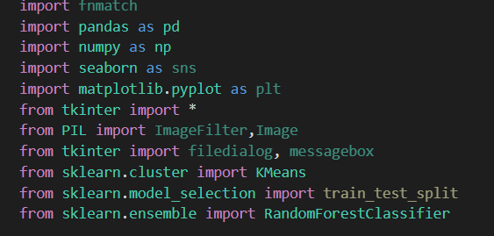

*Figure 2. Header Files used*

Pandas use for reading the dataset

Numpy used to convert features into numpy and then perform different further operations accordingly.

Tkinter is used for creation of the interface of the proposed system.

K-Means is used for clustering.

Train_test_split was used to divide the dataset into train and test portions to train and test the model.

Random Forest classifier is used to predict the the diseases based on the symptoms.

**Step 2. Training and Testing the Data**

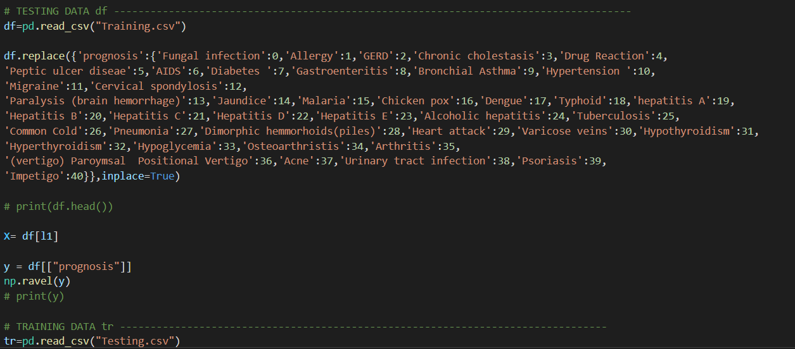

*Figure 3. Training and testing of the Data*

The data in the csv files that are to be used for training and testing of various diseases and their symptoms are being implemented on various methods of classifiers, such as the random forest, the naive bayes, and decision tree making. The data is being used to analyse the symptoms of various diseases and predictions are being made on the basis of that. The set of csv files training and testing helps to give outa a set of symptoms and a set of diseases that are present in the current situation by analyzing and predicting measures we can determine that the confusion of the people about any disease can be particularly resolved.

**Step 3. Analysing the data using Classifiers and calculating accuracy**

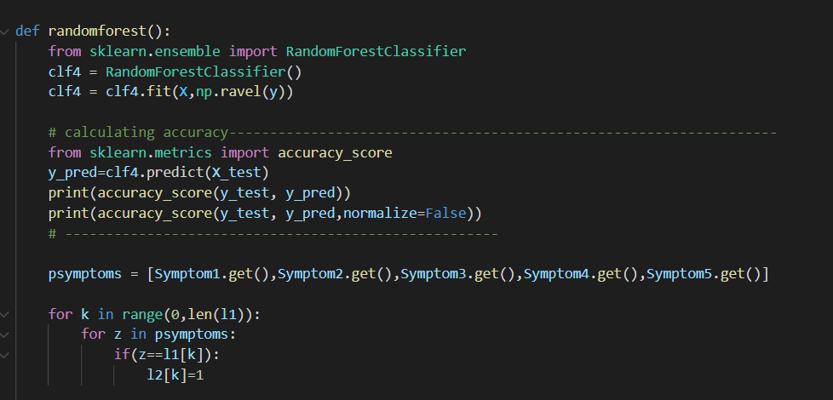

*Figure 4. Using Classifiers for Analysing*

The data of the files will be tested by different classifiers techniques so that the prediction can be done on that basis. Not only one classifier technique will be used if one fails, the other two will respond accordingly. The use of the prediction system is necessary because people have been confused between different diseases and their symptoms for a long time. This system not only resolves that problem that most people have been having.

**Step 4. Adding of GUI interface**

The system must have a graphical user interface (GUI) through which the patient can enter his or her set of symptoms. The patient simply needs to select from a list of symptoms that are already listed in the symptoms set. Based on the symptoms, the prediction technique works, and with the help of various classifier techniques, it can predict which disease is causing the patient's symptoms.

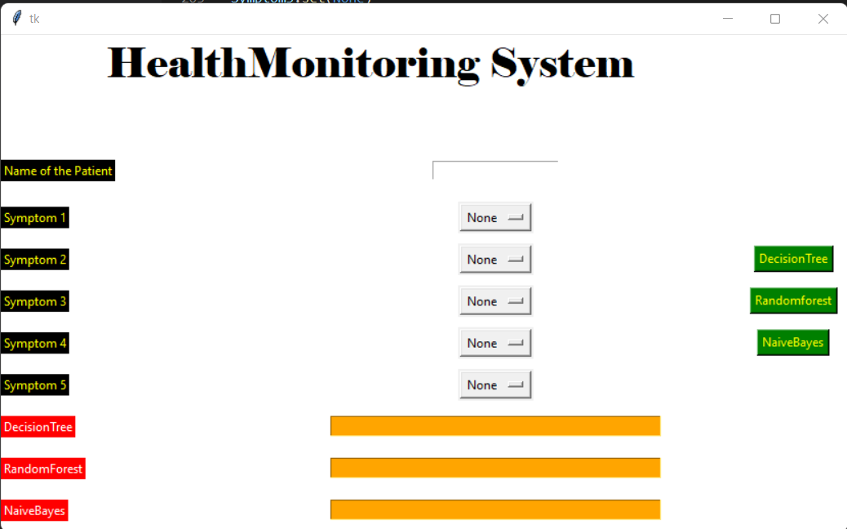

*Figure 5. GUI Interface*

The GUI interface of the system have the part where the patient can enter its name and then the set of 5 symptoms one patient can enter and on the basis of that set the prediction can be done by the classifiers, one can also choose its desired prediction technique that may help in better prediction but in most of the cases the techniques give out the same result in all cases. With the help of Tkinter (python module used for graphical interface) there is a communication can be generated between the patient and the the health monitoring system.

**RESULT**

After all of the above steps have been completed successfully, the result should be in the form of a GUI interface created with Tkinter (a Python library for creating graphical user interfaces). The prediction techniques used in this system are quite accurate in themselves and help to predict the proper disease based on their training and testing dataset. The system can cluster the data and then train and test the data using various techniques to produce the best prediction.

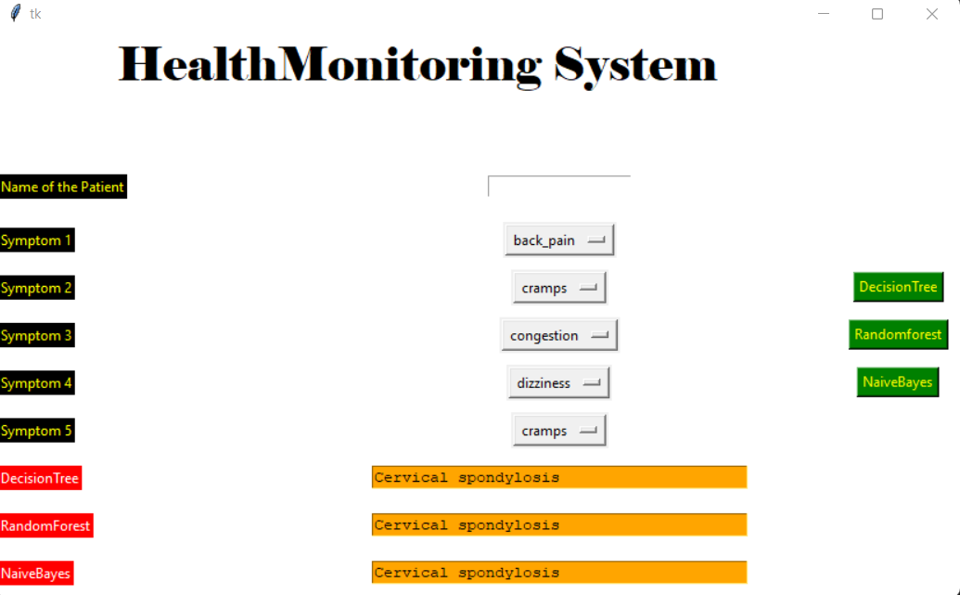

*Figure 6. Result of the Health monitoring system*

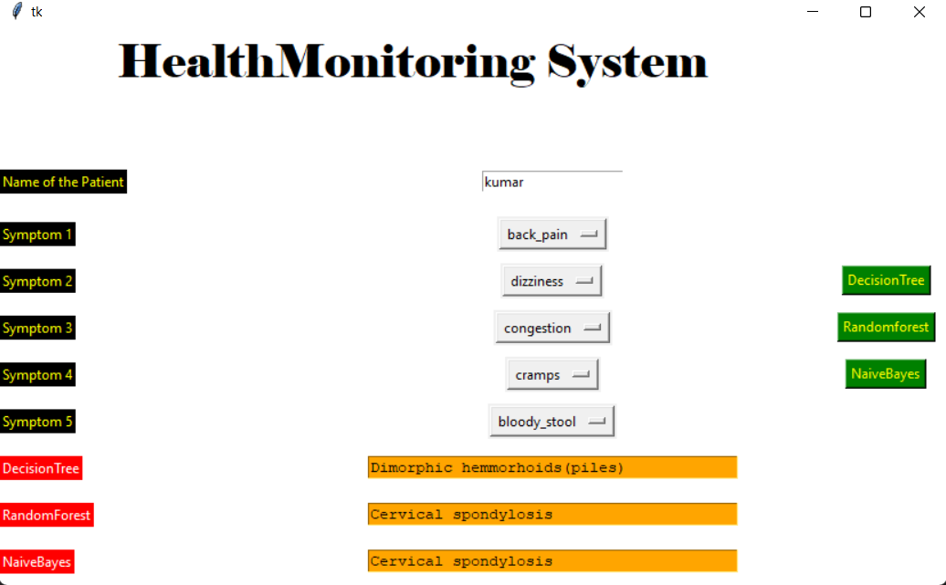

*Figure 7. Result in conflict of algorithm cases*

There is a conflict between the data in the training and testing phases because the system is still in the testing phase and the data set is much larger, so there is a chance that there might be clashes or incorrect predictions, but there is also a thing that the patient must keep in mind that the symptoms that are entered must be in appropriate order otherwise the prediction may come out incorrect in conflict situation the patient can go with the tested two output of the classifier techniques the accuracy is pretty good and there is a lot of scope of improvement can be done in this field. The larger the data we have and better features of algorithms if used this system must give out a plenty set of prediction that can be useful in the field of the health for the greater cause.

**Conclusion**

The proposed system problem statement is based on the fact that people nowadays are very curious to know what kind of disease they are suffering from, especially if they have mild symptoms. We used to search all over the internet for answers, but we never got the perfect answer; instead, we got a lot of unwanted results, which made us more panicked and scared. So here comes the suggested system in light, which is a machine learning based python IDE based system that will accept the user's symptoms data and classify it using its different classification and other main algorithm approaches to anticipate the patient's presumed ailment. There are two training and testing datasets used in it to make the prediction bit clearer and easier to understand by the user the user can have a set of five symptoms which are to be entered by the patient and on the basis of that the system can analyse it which is the exact predictable disease for the given set of symptoms there are three different machine algorithms used so that the accuracy of the system can be improved. There is a conflict between the data in the training and testing phases because the system is still in the testing phase and the data set is much larger, so there is a chance of clashes or incorrect predictions, but the patient must keep in mind that the symptoms must be entered in the correct order or the prediction will be incorrect. In a conflict situation, the patient can choose between the tested two outputs of the system.

**Future Scope**

The suggested method uses a vast data collection to anticipate which illness criteria the patient would meet, as well as suggest a hilly diet and activity pace in the patient's everyday life. The objective is to improve the accuracy of this system by analysing a huge set of patient data. The first method is to proceed with the diabetes and other ailments that the patient is likely to develop. In order to give a better customer interactive experience, the system will attempt to anticipate the outcome with increasing accuracy. The future scope of the proposed system is quite intriguing; if the proposed system can be connected to a set or a cloud of datasets with a large amount of training and testing data, then the outcome must be much more precise; additionally, the algorithms that are being used must be more specific and predictive, or to put it another way, more accurate; therefore, the outcome must be quite interesting. Becoming anxious as a result of online searches for their symptoms and receiving strange replies If we talk about the system's GUI interface, the system uses a python-based GUI called Tkinter, which is pretty old fashioned. The system can be connected to the frontend either through API to communicate with users in a better way, or by giving a better platform so that people can live a hassle-free life and get nervous less by surfing and searching for their symptoms and getting strange answers from the internet. When it comes to the system's graphical user interface, the system employs a Python-based GUI called Tkinter, which is quite outdated. Aside from that, there is a lot of work that can be done in the field of system deployment and maintenance to keep track of every patient on the internet by providing a better platform so that people may live a stress-free life and feel less scared when browsing.is using a pythoin based GUI Tkinter that is preety old fashioned the system can be connected to the frontend either by help of APIto communicate with user in a better way.

**Acknowledgement**

With profound respect, I express my deepest appreciation to Dr..Mandeep Kaur, Assistant Professor in the Department of Computer Science Engineering at Sharda University, for his support & cooperation in the completion of this study. Working with him has taught me a lot, and We will always be grateful for his contribution to my life.

**References**

**[1]** Yong-Yuan Deng, Chin-Ling Chen, Woei-Jiunn Tsaur, Yung-Wen Tang, and Jung-Hsuan Chen, “Internet of things (IoT) based design of a secure and lightweight body areanetwork (BAN) healthcare system”, Sensors, vol. 17, no. 12, pp. 2919, 2017.

**[2]** Mr. Ravish Gupta, Dept. of Electronics and Communication Engineering Smart Health Monitoring and Management Using Internet of things Artificial Intelligence Cloud based processing 2017.

**[3]** Mr. Adars , Vinayaka Mission’s Kadakkal, Kollam, Kerala study on an iot based securehealthcare monitoring system using cryptography 2017.

**[4]** G Sahithi , P Vinayasree , Pallati Narsimhulu real time health monitoring using iot with integration of machine learning approach 2019.

**[5]** Md. Milon Islam , Ashikur Rahaman ,Md. Rashedul Islam Development of Smart Healthcare Monitoring System in IoT

Environment 2018.

**[6]** V. Deepa, K. Rajeswari Analysis on E-Healthcare Monitoring System with Iot and Big Patient Data 2017.

**[7]** Srivardhan Reddy K1, Sidaarth R2, Sai Aneesh Reddy3, Dr. Rajashree Shettar IoT based Health Monitoring System using Machine Learning 2019.

**[8]**  Tzen Ket Wong ,Hou Kit Mun, Swee King Phang, Kai Lok Lum and Wei Qiang Tan Real Time Machine Health Monitoring System Using Machine Learning and IOT 2018.

**[9]** Tzen Ket Wong , Hou Kit Mun , Swee King Phang, Kai Lok Lum and Wei Qiang Tan Patient health monitoring using IoT with machine learning 2020.

**[10]** Aaditya Jain, and Bhupendra Kumar Soni, “Secure modern healthcare system based on internet of things and secret sharing of IoT healthcare data”, International Journal of Advanced Networking and Applications, vol. 8, no. 6, pp. 3283, 2017.

**[11]** Prabhu M, Seethalakshmi G and Gollapudi Anisha, “Secured healthcare system in IoT”, International Journal of Pure and Applied Mathematics, vol. 118, no. 20, pp. 3239-3244, 2018.